**Noname manuscript No.**

(will be inserted by the editor)

Mediation and Fuzzy Mediation Analysis for Multiple Covariates and Its Applications to Solar Power Data

Yeon Kyung Lee1,†· Jung Eun Lee1,†· Sung Wook Baik2 · and Jin Hee Yoon3,*

Received: date / Accepted: date

**Abstract** Recently, due to environmental problems caused by global warming, the importance of renewable energy is increasingly emerging. However, renewable energy such as solar energy has a problem that it is difficult to predict because the amount of power generation fluctuates greatly depending on the location of the sun, season, and climate. Even more, solar energy data includes lots of vague information such as the amount of cloud or temperature which is changing continuously. Therefore, it is needed to handle solar power data as fuzzy data. Since false forecasts consume a lot of fuel and operating costs, many previous studies have been conducted to predict solar power generation. Unfortunately, there have been few papers applying the fuzzy theory to solar energy data so far, and most of the studies have considered all weather information such as temperature, humidity, and wind speed as equal independent variables to build models for forecasting solar power data. In other words, previous studies focused only on increasing the prediction rate of solar power generation, but studies to figure out the relationship between actual variables were insufficient. It is important to accurately understand the relationship before prediction. Therefore, in order to analyze the causal relation of the variables of a solar power data, it is needed to employ a delicate model which deals with the independent variables in a detailed way. For this, we proposed a mediation analysis for multiple covariates that can be applied to fuzzy data.

1 Department of Mathematics and Statistics, Sejong University, Seoul 05006, South Korea ; {wheeboo, leeyeonkyung}@naver.com

2 Department of Software, Sejong University, Seoul 05006,

Korea;[sbaik@sejong.ac.kr](mailto:sbaik@sejong.ac.kr)

**\***Correspondence: [jin9135@sejong.ac.kr](mailto:jin9135@sejong.ac.kr); Tel.: +82-10-9118-3135

**†** These two authors contributed equally to this work.

It is known that weather information affects solar radiation, and solar power is hugely affected by this solar radiation. So, in this study, the solar radiation is defined by a mediator to analyze direct effect, indirect effect, and total effect to the solar power. In addition, we confirmed that the proposed fuzzy mediation model explains the causal relation of the variables more detail and accurate than the crisp mediation model.

**Keywords:** Causal relationship; Mediation Analysis; Fuzzy Mediation Analysis; Covariates; Solar Power Data

# 1 Introduction

Globally, energy consumption is skyrocketing due to economic growth and development. Recently, due to the exhaustion of fossil fuel resources, carbon dioxide emission regulations, and the dangers of nuclear power generation caused by natural disasters, people have become more and more interested in the research of renewable energy. Among them, photovoltaic power accounts for more than half of the world’s new power generation capacity along with wind power. According to the BNEF ‘Power Transition Trend 2020’, the proportion of solar power and wind power increased from 24% in 2010 to 67% in 2019. In this way, photovoltaic power generation is widely used due to its advantages such as relatively free development location conditions, safe and long equipment life, and infinite energy source compared to other energy sources [1]. But there is a problem that the output fluctuates sharply depending on the position of the sun, and the amount of power generation fluctuates greatly depending on the season and the weather, making it difficult to predict [2-5].

False forecasts consume a lot of fuel and operating costs, while accurate forecasts can reduce the number of many backup power plants currently in operation. Therefore, for efficient power production, it is necessary to study a model that can be stably linked to the power system [2].

Solar Power prediction models using existing weather information data have statistical methods such as ARMA(Autoregressive Moving Average), ARIMA(Autoregressive Integrated Moving Average) [6,7] and machine learning methods such as SVM(Support Vector Machine), ANN(Artificial Neural Network), LSTM(Long Short-Term Memory) [8-12].

Huang et al.(2012) confirmed that the persistence model performs well in very short term period, while the ARMA model shows excellent results in short and medium term solar predictions[6]. S. Atique et al.(2019) established and tested a model to predict the total daily solar energy generation of a research facilities using the ARIMA model[7]. H. Lee.(2016) conducted a study that calculated the moving mean and slope for input variables temperature, humidity, and insolation to reflect new features and applied models generated by neural network, SVM, and RBF as ensemble techniques[8]. Jeong et al.(2016) compared and analyzed three predictive models: ANN, SVM, and ANFIS by setting slope insolation, horizontal insolation, external temperature, and solar module temperature as input variables which are highly correlated with solar power generation[9]. K. Lee et al.(2016) first calculated the amount of solar radiation by generating weather forecasts, solar altitude, and derived variables, then finally predicted the amount of power generation using the SVR algorithm[10]. J. Jeong et al.(2018) conducted a study to compare and analyze the performance prediction of solar power according to the importance of each independent variables and the presence of solar radiation using RF, SVM, and ANN as a prediction model[11]. H. Son. et al.(2020) designed the LSTM network to be multi-step predictable, and compared the performance according to the inclusion of weather forecast data variables[12].

However, some of the studies predicted the current solar power generation by analyzing only the pattern of past power generation[6,7]. Also, solar radiation has been regarded as an independent variable such as other climatic information, that is, temperature, humidity, and wind speed. Especially, the solar radiation was used as a unique independent variable in order to predict the amount of solar power generation [8-10]. Moreover, some studies only focused on selecting variables while analyzing whether the predictive power of the model was high when certain variables were inserted as input variables [11,12].

In other words, in previous studies, there were studies such as analysis of the change pattern of solar power generation as time series data, the relationship between meteorological information including the amount of solar radiation and the amount of photovoltaic power generation, selecting the best combination of variables for predicting the amount of solar power generation. But, after all these analyzes, there is a lack of research to understand the relationships with variables.

In fact, since meteorological variables affect solar radiation and this affects solar power generation, research is needed to set solar radiation as a mediator rather than to regard it as a combination of weather variables or solar power.

When independent and dependent variables are influenced by another variable, a mediator plays an important role in data analysis with many variables [13]. Mediation analysis tests statistical significance by setting mediators between independent variables and a dependent variable. So using mediators helps us can find a model which is closer to the real relationships between variables than not using them. There are some methods used to conduct a mediation analysis; Causal steps approach by Baron and Kenny(1986), Sobel test, and Bootstrap method [13-14]. Among them, Casual steps approach is the first proposed mediation analysis method and the most frequently used in all fields of studies that require regression, including social psychology, education, medicine, and engineering area, etc[15-20]. It is implemented in 3-step, the regression between an independent variable and a mediator, the regression between an independent variable and a dependent variable, and the regression between a mediator and a dependent variable.

Unfortunately, in previous studies, there was only a mediation model with one independent or covariate, therefore, it is necessary to deal with a mediation model for multiple independent variables or covariates.

In addition, the data in this study also use fuzzy numbers. Fuzzy number, first introduced by Zadeh, is a number intended to express ambiguous human language as a computer language[21]. Observations such as actual weather information, solar radiation, and solar energy generation require fuzzification because they are observed with ambiguous values rather than crisp values[13]. In fact, the data we need is not accurate values such as solar energy generation at a certain time point. Therefore, instead of having a particular value represent the data, this paper is conducted with the possibility of the surrounding values.

This study is an extended study of Yoon J.H.(2020). Yoon J.H.(2020) proposed fuzzy mediation, moderation and moderated-mediation analysis with one independent variable or covariate and provided confidence intervals and performed hypothesis for total, direct, indirect effects.

In this paper, four models are proposed. Two of them are mediation models for multiple independent variables or covariates when there is one mediator or multiple mediators. The other two are the fuzzy versions of the previous two models. Applying the models with one mediator to the solar power data, this study assumed that there is a mediator statistically significant and indirectly affects predicting the amount of solar power through weather conditions. Therefore, this study analyzes whether solar radiation mediates weather conditions with solar power by setting weather data as independent variables, solar radiation as parameters, and solar power as dependent variables. In addition, this paper compares the mediation models using crisp and fuzzy data then derives statistical inference of total, direct, indirect effect.

# 2 Simple Mediation Analysis and Fuzzy Mediation Analysis

**2.1. Simple Mediation Analysis**

Simple mediation model by Baron and Kenny is derived from a single regression. It implemented in 3-step, and we conduct a simple regression 3 times.; A regression between an independent variable and a mediator, a regression between an independent variable and a dependent variable, and a regression between a mediator and a dependent variable. The equations and figures in this section refer to Baron and Kenny [13] (See Fig.1.(a), (b)).

In this model, and are significant, and should be bigger than . ( Why?) is the “total effect”, is the “indirect effect”, and is the “direct effect”, and it is easily checked that We can examine whether we conduct analysis in a right way by checking sum of direct effect() and indirect effect() is same with total effect().

As the real world is full of complexity and correlativity, it is often appropriate to use a multiple mediation model instead of a simple mediation model. In a basic multiple mediation model, mediators operate in parallel, so they don’t affect other mediators. (See Fig.1.(e))

when

From above model, is the “total effect”, is the “indirect effect” on through the mediator , and is the “direct effect”, and it is easily checked that by simple calculation.

These coefficients can be obtained using various types of estimation techniques of regression model based on the given data types. In this paper, the least-squares estimation has been applied.

(a) Simple regression

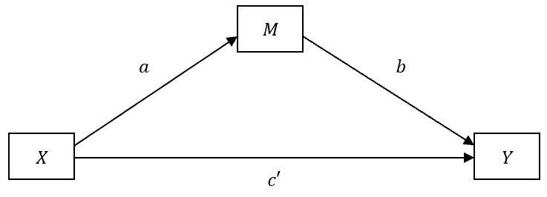

(b) Simple mediation model

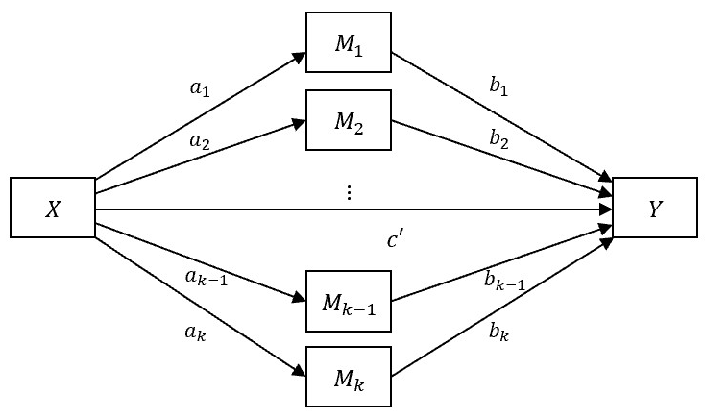

(c) Parallel multiple mediation model

**Fig 1** The simple regression model and mediation models

**2.2. Simple Fuzzy Mediation Analysis**

In this section, we introduce the definition of fuzzy numbers by Zadeh [21] and simple fuzzy mediation models with mediators introduced by Yoon [22].

**2.2.1 Fuzzy numbers.**

A fuzzy number is a generalization of a real number by representing a continuous set of possible values between 0 and 1, not one value. Each element of the fuzzy set A has a degree that belongs to that set, which is defined by a function called a membership function . In fact, general rules do not exist in fuzzy observation. Therefore, as a specific case, the parametric class of fuzzy numbers, called LR-fuzzy numbers are used.

where '*m*' means the mode of the fuzzy number *A*, and '*l*' and '*r*' mean the width of the left and right. And L,R: are left-continuous and not increasing function with R(0) = L(0) = 1, R(1) = L(1) = 0. We abbreviate the LR-fuzzy number as.Also, LR-fuzzy numbers follow the following two operations.

= (,

.

**2.2.2 Simple Fuzzy Mediation Model**

If the variables have ambiguous characteristics, it is much more effective to analyze them using fuzzy numbers than crisp numbers. Fuzzy mediation model can be suggested as follows:

In the above model, is the total effect, is the indirect effect, and is the direct effect. Note that it is easily checked that

A simple fuzzy mediation analysis model with multiple mediators is proposed by:

where

In the above model, is the total effect of on , is the indirect effect through and on , and is the direct effect of on . We can check that

So far, various mediation models for multiple mediators, moderators or confounding variables have been proposed by [23-25]. But, unfortunately, a mediation model for multiple independent variable or covariates has not been dealt with any authors yet. Next, we first propose mediation models for multiple covariates with mediators in Section 3, and fuzzy mediation models for multiple covariates with mediators in Section 4.

3. Mediation Analysis for Multiple Covariates

In this section, we propose mediation analysis models for multiple covariates with one mediator and multiple mediators.

**3.1. Mediation Analysis for Multiple Covariates with one mediator**

We propose a mediation model for multiple covariates, especially multiple independent variables with a mediator as follows:

where

From above model, is the total effect of on , is the indirect effect on through and and is the direct effect of on We can check that

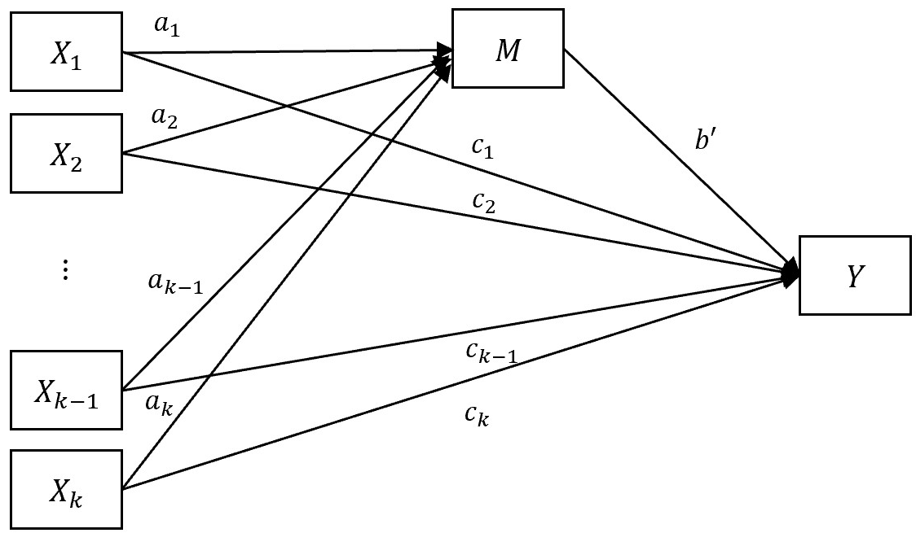

**Fig 2** Mediation with multi-independent variables and a mediator.

**3.2. Mediation Aanalysis for Multiple Covariates with multiple mediators**

Next, we propose a mediation model with multiple covariates and multiple mediators as follows:

where and

Here, is the total effect of is the indirect effect on through and , and is the direct effect. And it can be easily checked that ( and ).

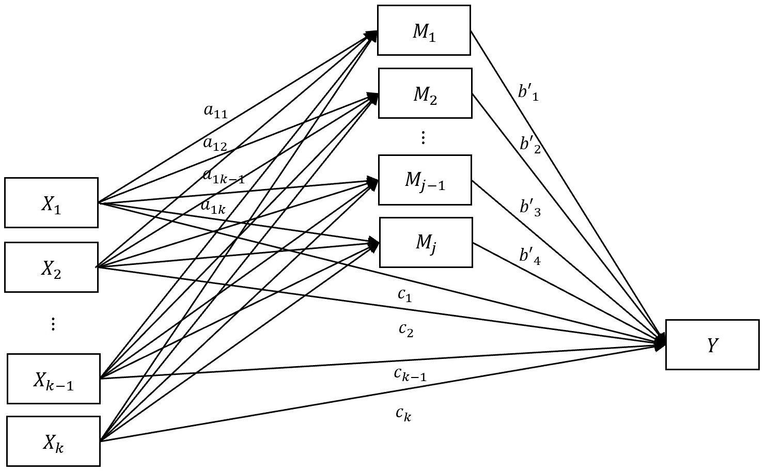

**Fig 3** Mediation with multi-independent variables and multi mediators.

4. Fuzzy Mediation Analysis for Multiple Covariates

**4.1. Fuzzy Mediation Aanalysis for Multiple Covariates with one mediator**

When there are several independent variables, especially if the variables are vaguely observed, a fuzzy mediation analysis model can be proposed as follows:

,

where

Here, is the total effect of is the indirect effect on through and , and is the direct effect, and it is easily checked that ().

**4.2. Fuzzy Mediation Analysis for Multiple Covariates with multiple mediator**

Even more, when the variables are vaguely observed, and if there are several mediators, then a fuzzy mediation analysis model with multiple covariates and multiple mediators can be proposed as follows:

,

where and

Here, is the total effect of is the indirect effect on through and , and is the direct effect, and it is easily checked that ( and ).

4.3. Estimation for Fuzzy Mediation Analysis for Multiple Covariates with mediators

For the least squares estimation with fuzzy data, a suitable metric is required on the spaces of fuzzy sets. Here, a useful type of metric can be defined via support functions. The support function of any compact convex set is defined as a function  given by for all

where is the (d-1)-dimensional unit sphere in and denotes the scalar product on . Note that for convex and compact the support function is uniquely determined. A metric on a fuzzy number set is defined by the *-*metric on the space of Lebesgue integrable

Based on this, an *-* metric for fuzzy numbers can be defined by

A fuzzy regression model which was introduced in author’s previous studies [24,25] that is proposed as follows:

.

The variables are represented by and for It is assumed that are the fuzzy random errors for expressing fuzziness. Note that we can encompass all cases by

where are the left and right spreads of respectively. Now the estimators is obtained if we minimize following objective function:

for *k=1,2,…,q*, where *q* is the number of the regression model in this fuzzy mediation analysis. And the objective function can be obtained based on the *-*metric, and here the *-* distance can be expressed as follows:

To minimize above equation, we obtain the normal equation applying

And, for each the normal equation, which has as solutions, can be obtained as follows:

To find the solution vector, we define a *triangular fuzzy matrix* *(t.f.m.)* which is expressed by

,

and denoted by in short, where is a triangular fuzzy number for And we define a triangular fuzzy vector

.

To minimize the above objective function, fuzzy operations fuzzy numbers and estimators which were defined in our previous studies [26-29] have been applied.

*.*

For given two *t.f.m*'s, , , and a crisp matrix the operations are defined as follows:

,

*,*

*,* .

.

Using the above operations and algebraic properties, the solutions of normal equation fuzzy estimators are derived for each by

where

and , for Note that (16) exists if .

5. Statistical inferences of Mediation and Fuzzy Mediation Model for Multiple Covariates

This section proposes statistical inferences such as confidence interval and test statistics for the proposed models in section 3 and section 4.

**5.1 Inferences on the total and direct effect**

Based on the general assumption that the least squares estimators are normally distributed, we can consider statistical inferences on the mediation models and fuzzy mediation models. From our previous studies [12,20], the proposed fuzzy least squares estimator (16) is asymptotically normally distributed. When the population variance is unknown *t*-distribution can be applied. But when the dataset is large, *z-*value can be applied asymptotically. Hence, confidence interval for total and direct can be expressed by

*CI for the total effect :*

*CI for the direct effect*

respectively. Here, let us define standard error of the total and direct effect:

where and Here CSD means sample standard deviation for crisp mediation model and FSD means sample standard deviation for fuzzy mediation model.

For a sample mean , following property can be applied [26-29].

*,*

where is a fuzzy random variable.

In addition, hypothesis tests

,

,

are performed asymptotically based on following test statistic under :

for the total effect and direct effect respectively.

**5.2. Test statistics for fuzzy mediation model with multiple covariates**

The normal theory approach for the indirect effect is sometimes mentioned by “Sobel test” or “delta method”, or the “product of coefficients method” [30,31]. The indirect effect *ab* is estimated value of based on sample. It is known that

where (first order standard error estimator) or (second order standard error estimator). Here, are the standard error of and *b*, respectively. It is known that there is no significant difference between the first and second order standard error estimator [19]. In this paper the second order standard error estimator has been used. Therefore, the confidence interval is asymptotically expressed by

*CI for the indirect effect*

where .

Based on above assumptions, the hypothesis test

,

is performed asymptotically based on following test statistic under :

6. Fuzzy Mediation Analysis with Multiple Covariates for Solar Power Data

This data was collected every hour from 1 a.m on January 1, 2015 to 11 p.m. on December 31, 2017 at Dangjin solar energy facilities in Korea. In data, 48 missing values are observed and because of the tendency that solar power changes continuously, they are processed through linear interpolation. In addition, in order to adjust the data distribution, it is normalized. Also, in order to find significant variables affecting solar energy, after linear regression, which sets 8 variables (temp, rain, windspeed, humidity, sun hour, solar radiation, sow, cloud) as independent variables and solar power as a dependent variable, all p-value was almost zero, so all variables are considered significant.

6.1 Estimation of total effect, direct effect, and indirect effect

The following is our multi independent variables fuzzy mediation analysis model.(Fig 4)

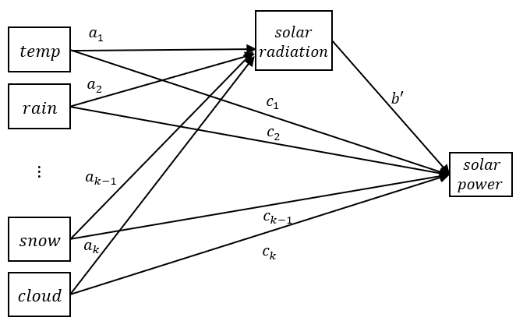

**Fig 4** Mediation with multi-independent variables and multi mediators for solar power data

The total effect is expressed by sum of direct effect and indirect effect. By comparing the total effect of CMA and FMA (CMA: classical mediation analysis, FMA: fuzzy mediation analysis), we can estimate efficiency of our model.

**Table 1** Parameter estimates

(a) Parameter estimates between weather conditions and solar power

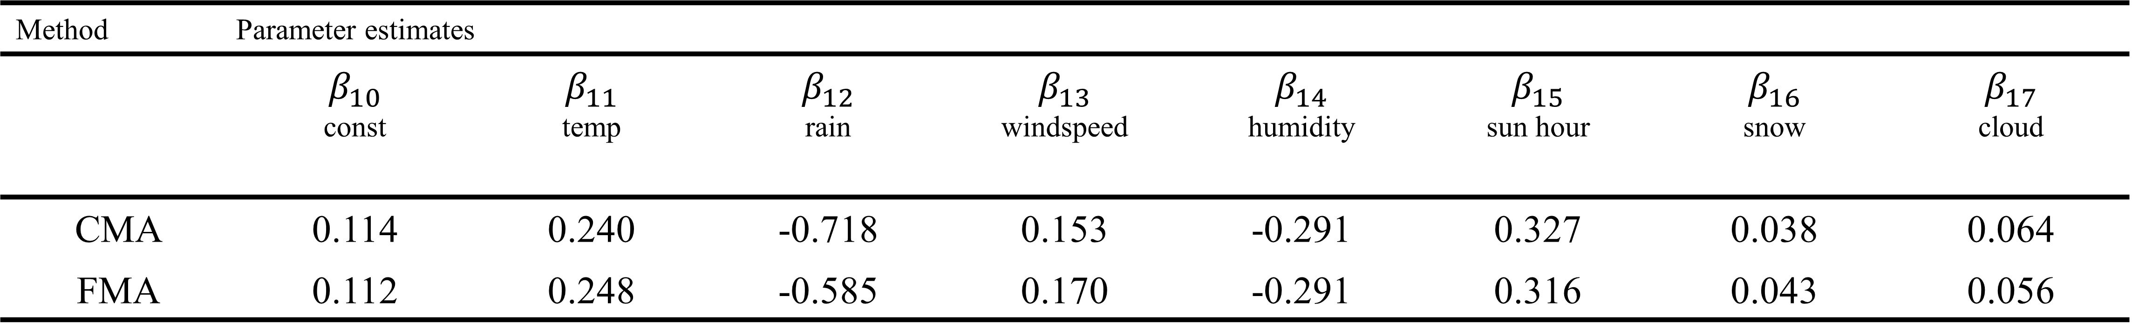

(b) Parameter estimates between weather conditions and solar radiation

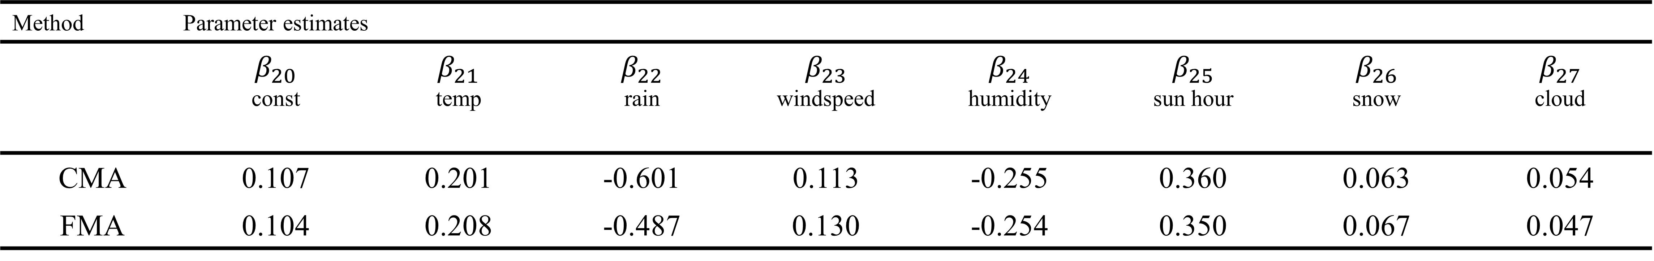

(c) Parameter estimates between weather conditions + solar radiation and solar power

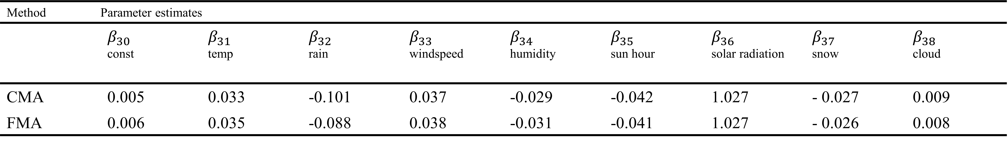

**Table 2** Effects of the weather conditions

(a) Effects of the temp

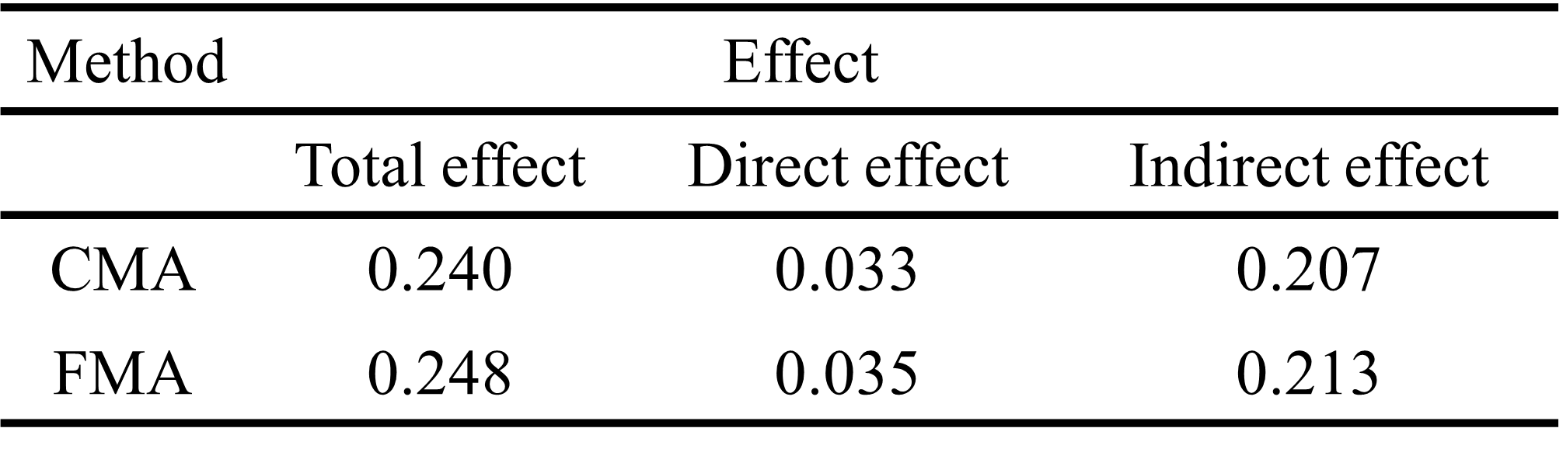

(b) Effects of the rain

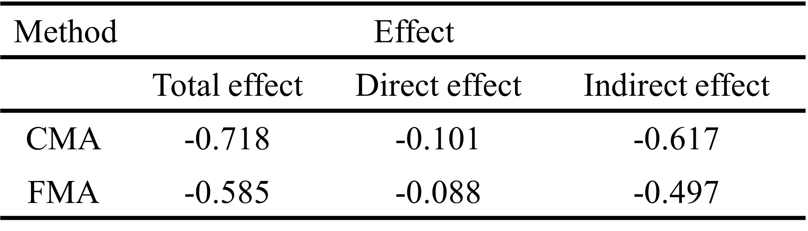

(c) Effects of the windspeed

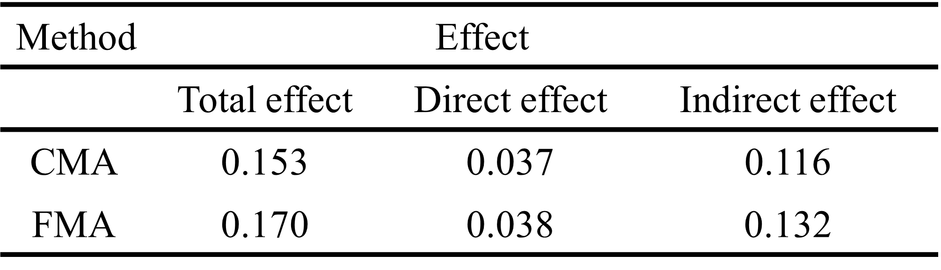

(d) Effects of the humidity

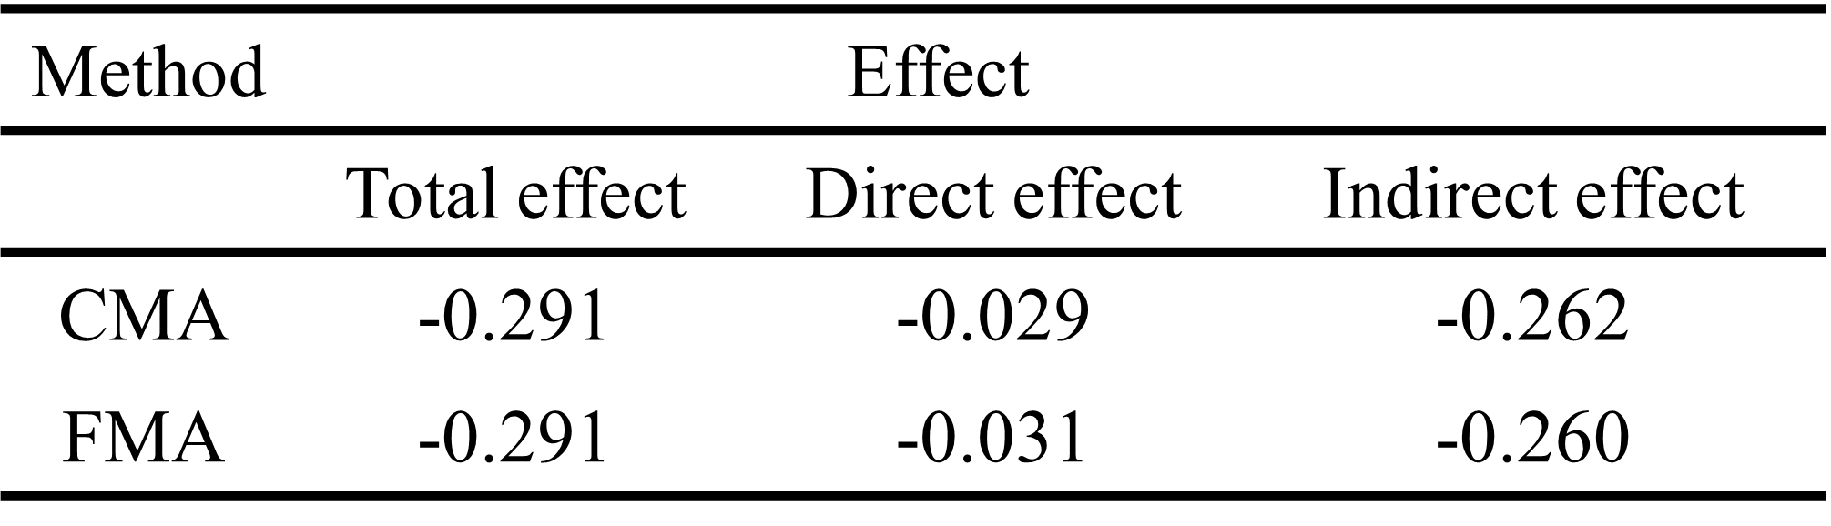

(e) Effects of the sun hour

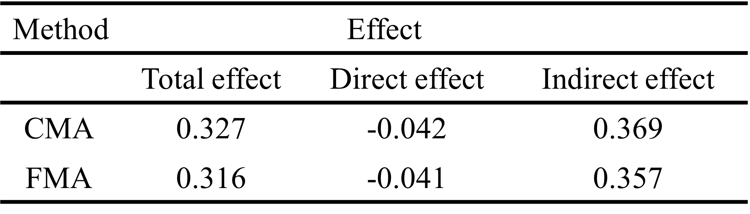

(f) Effects of the snow

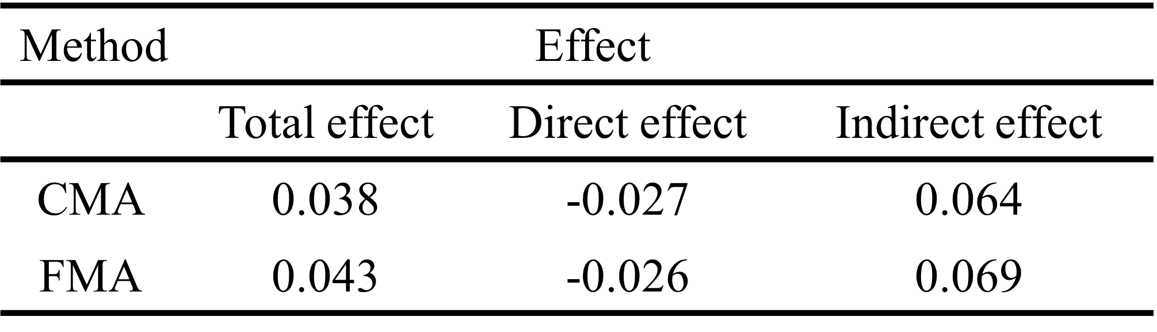

(g) Effects of the cloud

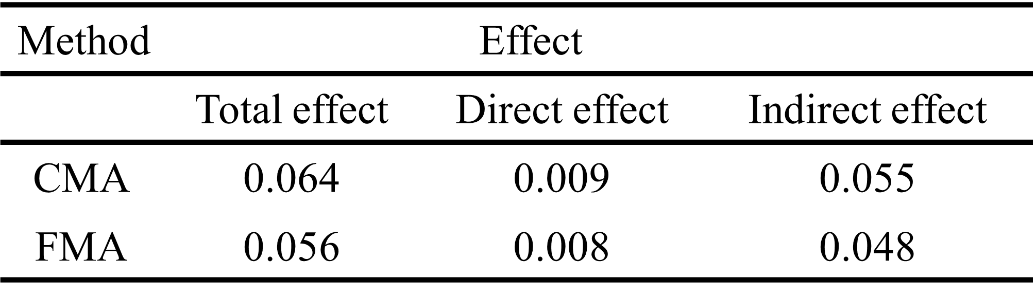

Table 1 shows the parameter estimates of the proposed model. And the estimation of total effect, direct effect, indirect effect are shown in Table 2.  
It is shown that when using fuzzy data which considers spread of data, in other words FMA, the result can be proposed to be more reliable than CMA. It can be seen that the total effect of CMA has a larger absolute value than the total effect of FMA, which can be considered to be excessively measured in CMA. Also, the direct effect, in which the independent variable directly affects the dependent variable, also resulted in the same result. Even the indirect effect, which is the effect of independent variables on the dependent variable through mediator, is found to have a positive value, not a negative value, when using the FMA.

**6.2 Inference About total effect, direct effect, and indirect effect.**

i) For 95% confidence interval for the total effect in FMA

95% CI for ,

where (Table 3)

For the hypothesis test: , the test statistic is

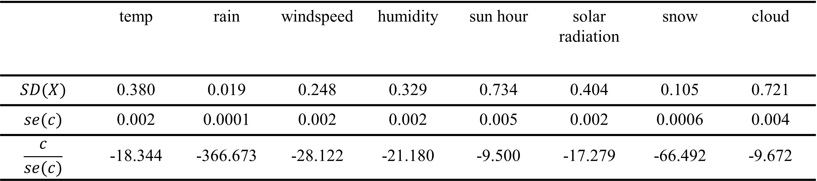

**Table 3** test statistic for the total effect

ii) For 95% confidence interval for the direct effect in FMA

95% CI for ,

where (Table 4)

For the hypothesis test: , the test statistic is

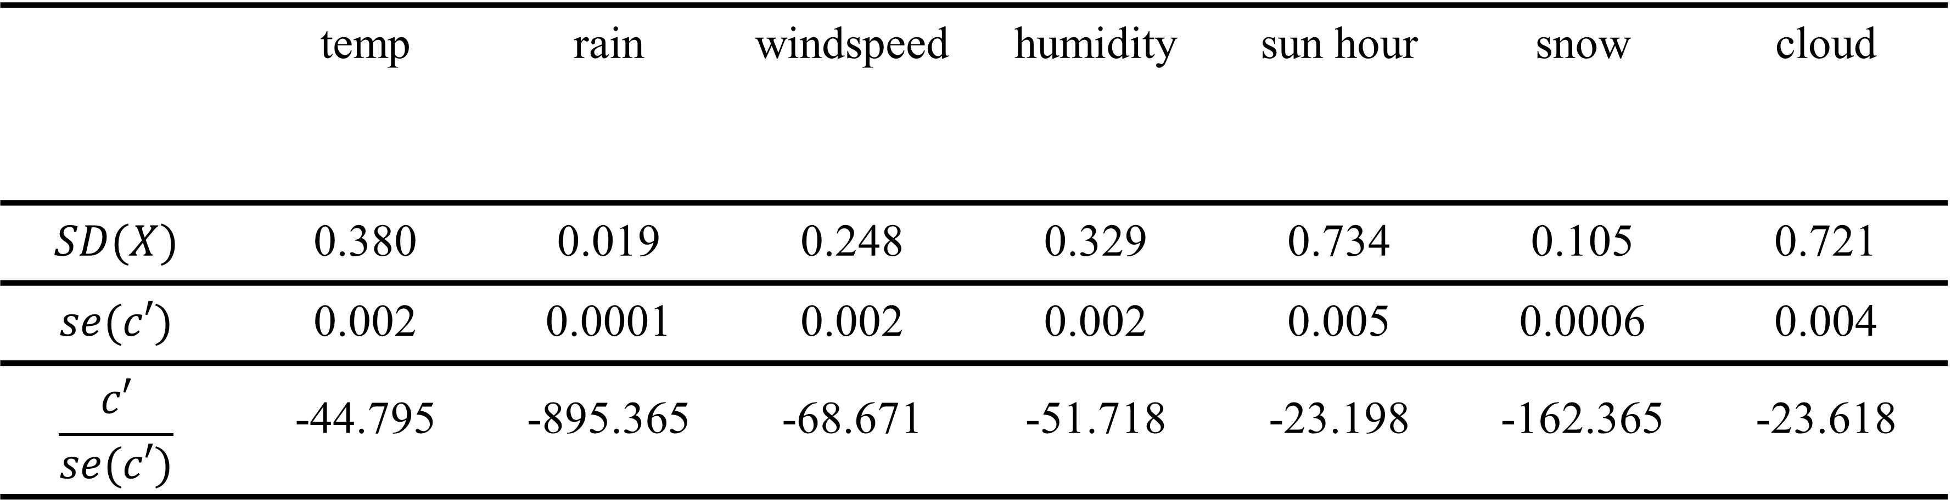

**Table 4** test statistic for the direct effect

From the Table 6-(b), with a level of significance The direct effect of the rain in weather conditions data does not significantly affect solar power in CMA. However the direct effect of FMA is significant.

iii) For 95% confidence interval for the indirect effect in FMA

95% CI for ,

(Table 5)

For the hypothesis test: , the test statistic is

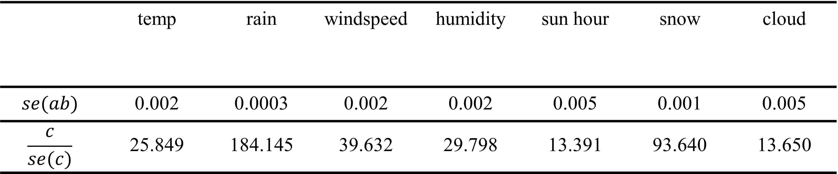

**Table 5** test statistic for the indirect effect

From the Table 6-(b), with a level of significance The indirect effect of the rain in weather conditions data does not significantly affect solar power in CMA. However the indirect effect of FMA is significant. In other words, in CMA, rejecting is not available in ‘rain’ variable, however, in FMA all independent variables can reject .

This result means that not considering ambiguous information can lead to biased results.

**Table 6** Statistical inference about total, direct, and indirect effect of weather conditions

(a) Statistical inference about temp

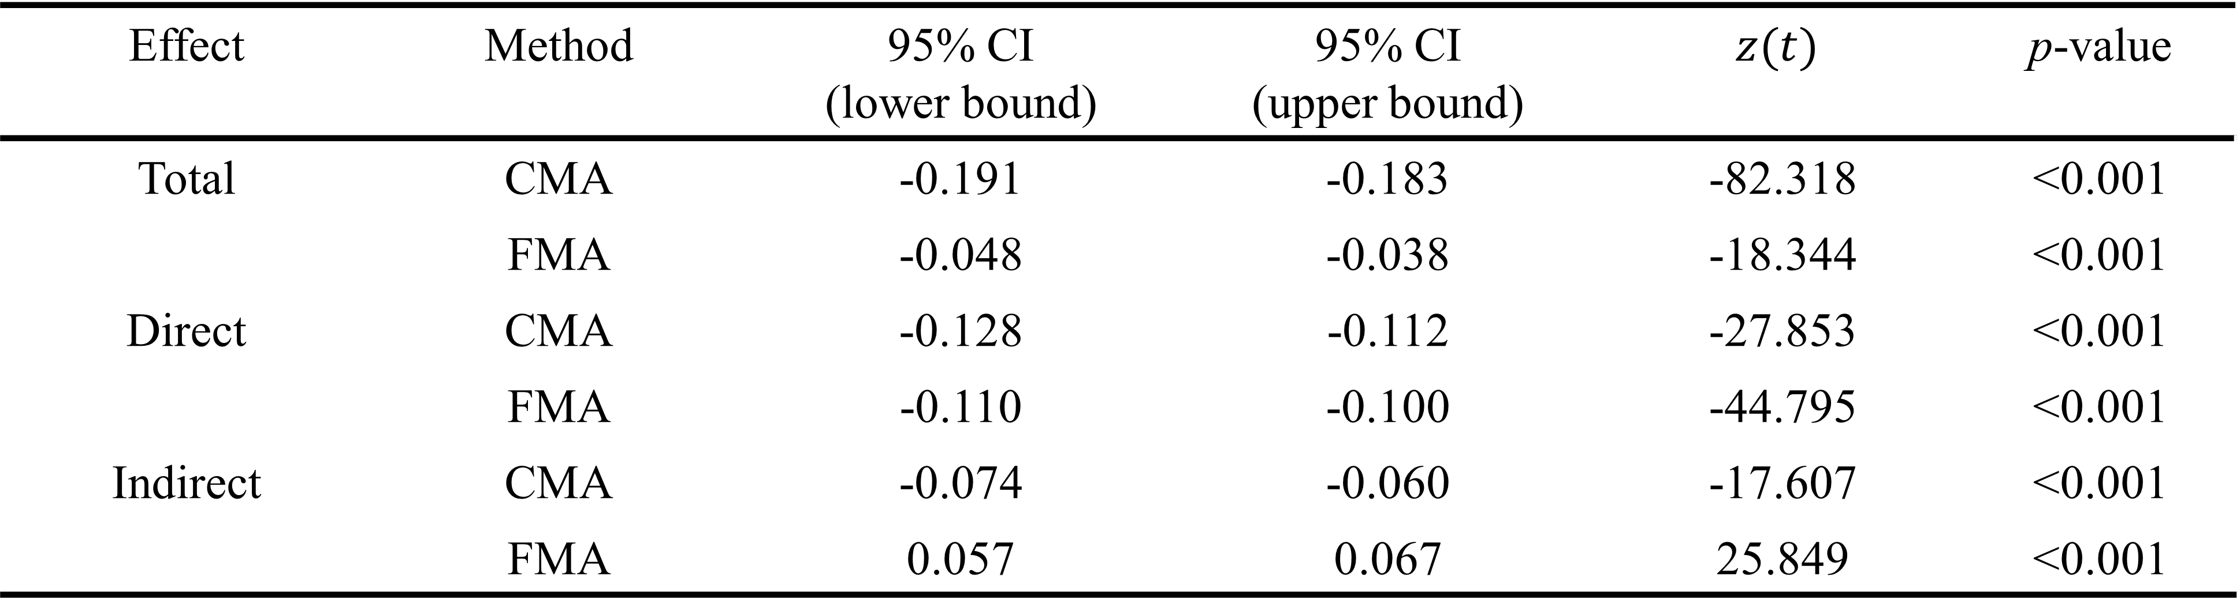

(b) Statistical inference about rain

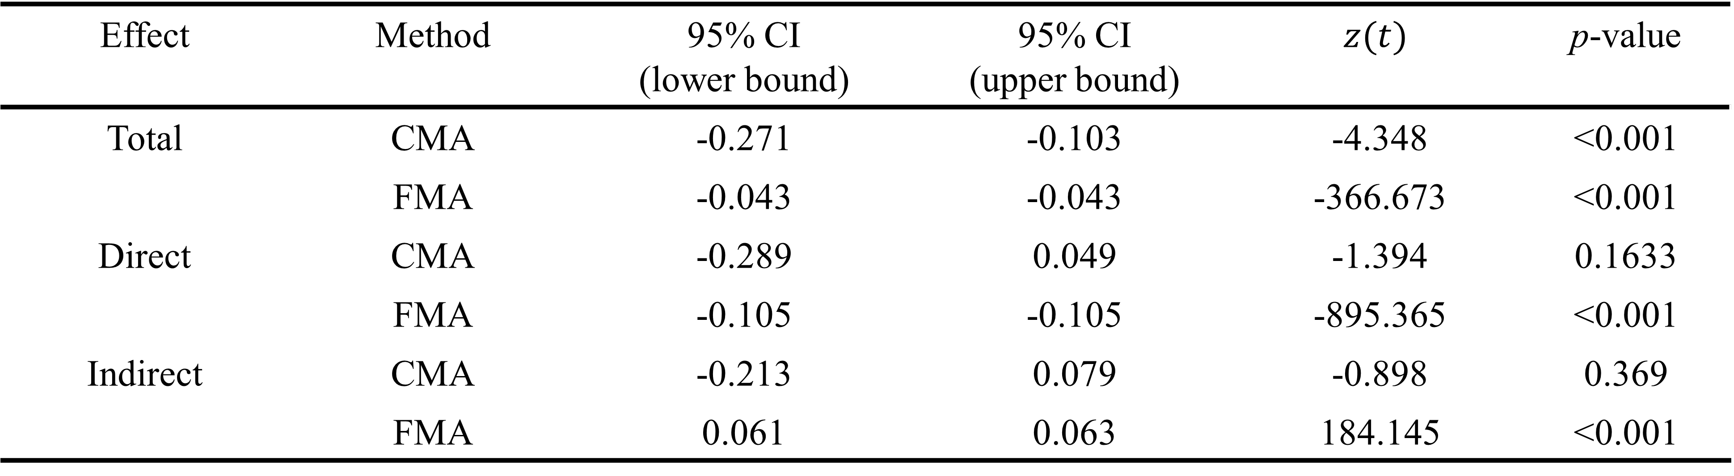

(c) Statistical inference about wind speed

(d) Statistical inference about humidity

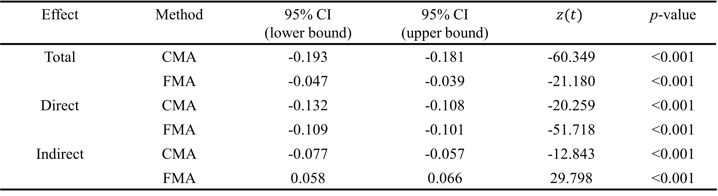

(e) Statistical inference about sun hour

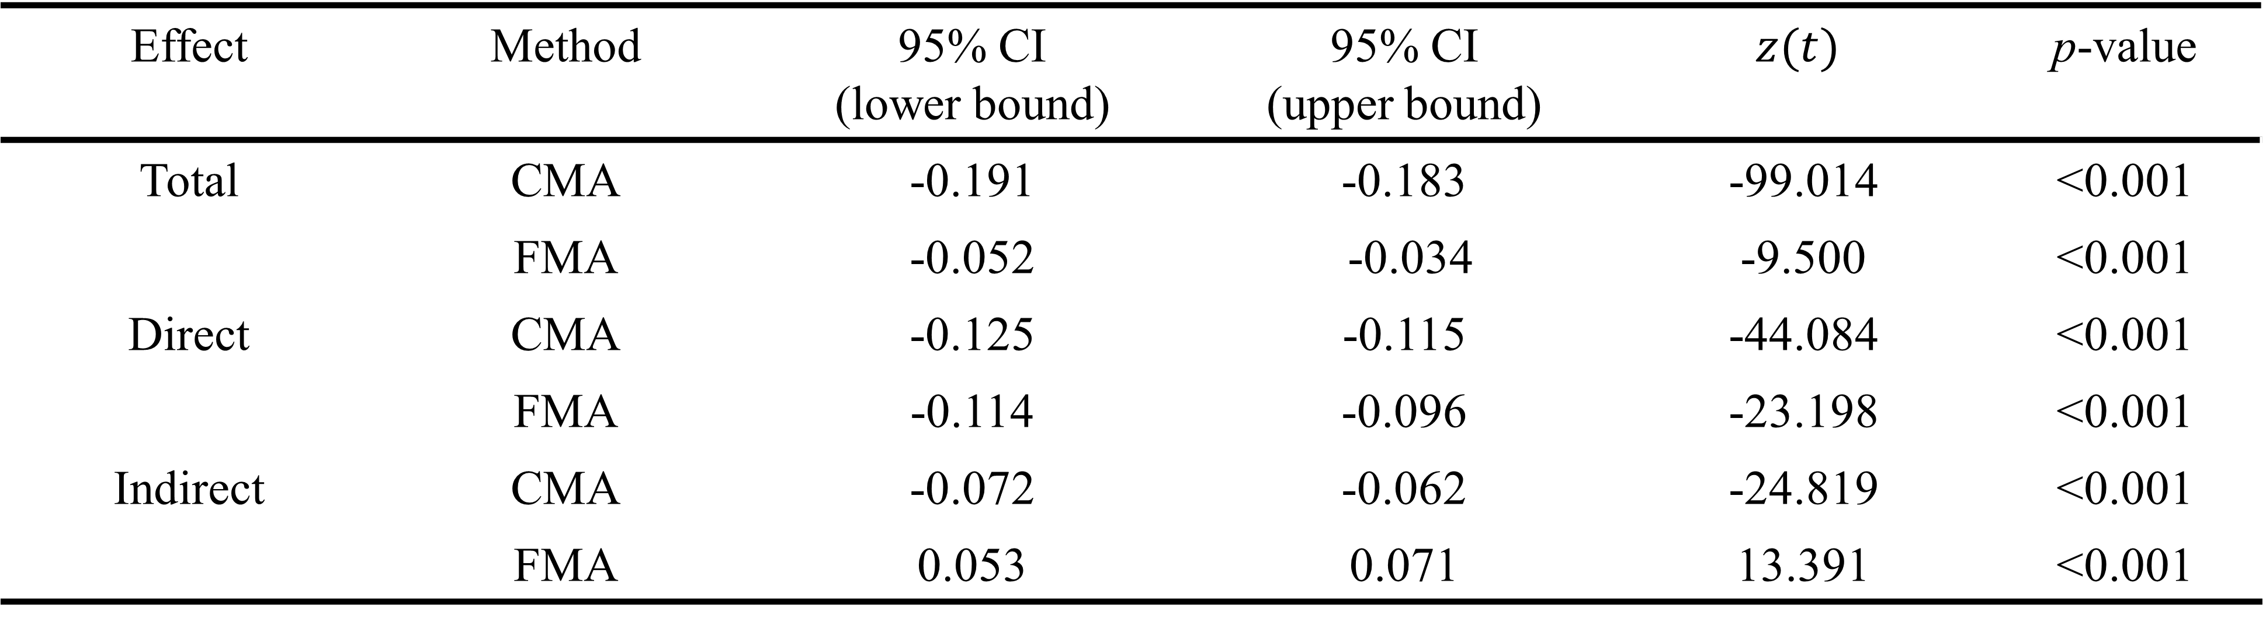

(f) Statistical inference about snow

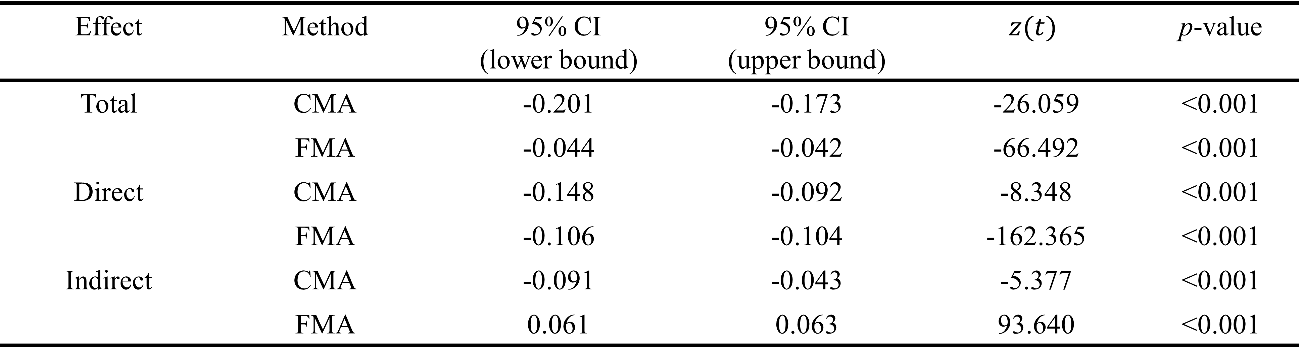

(g) Statistical inference about cloud

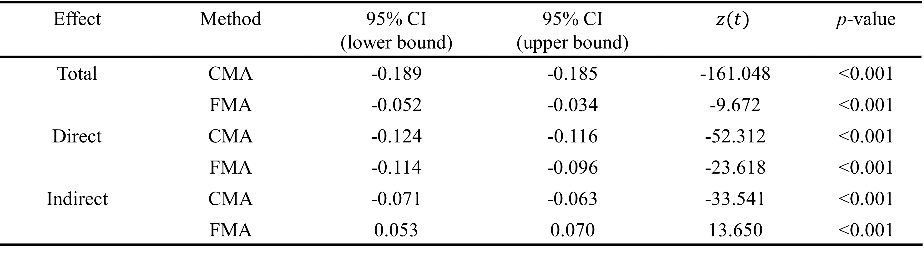

7. Conclusions

This study establishes a model CMA with multiple covariates in which solar radiation mediates weather information and solar power generation to understand the relationship between variables that affect photovoltaic power. In addition, a fuzzy model FMA is also established in consideration of ambiguous characteristics in which the boundaries of the observed values were not clear. The data was collected from solar energy facilities in Dangjin, Korea, and went through the process as follows. The missing values are processed through linear interpolation, the data values are normalized, and significant variables are selected after regression analysis and then fuzzified. Comparing the results of the parameter estimates of the two models, differences in total effect, direct effect, indirect effect are found, which means that FMA considering the spread value of data is more reliable than CMA using summarized data. In addition, statistical inference of above effects determines that the variable ‘rain’ does not affect the solar power in CMA, however, all variables are determined to have an effect in FMA. In other words, this also meant that biased results could be derived without considering the ambiguity of data. As a future study, model of this study will be expanded and used for mediation, moderation, mediation-moderation analysis.

**Author Contributions:** Conceptualization, methodology, investigation, writing, supervision, funding acquisition, J.H. Yoon; investigation, project administration, funding acquisition, S. Baik; software, data curation, validation, writing, funding acquisition, Y.K. Lee and J.E. Lee. All authors have read and agreed to the published version of the manuscript.

**Funding:** J.E. Lee, S. Baik and J.H. Yoon were supported by the National Research Foundation of Korea (NRF) grant funded by the Korea government (MSIT) (No. 2019M3F2A1073179). Y.K. Lee and J.H. Yoon were supported by the National Research Foundation of Korea(NRF) grant funded by the Korea government(MSIT) (No. 2020R1A2C1A01011131).

**Conflicts of Interest:** The authors declare no conflict of interest.

References

1. Kim, B., Jung, S., Kim, M., Kim, J., Lee, H., & Kim, S.: Solar Power Generation Forecasting based on LSTM considering Weather Conditions. Journal of Korean Institute of Intelligent Systems. **30**(1), 7-12 (2020)

2. Song, J., Jeong, Y., Lee, S.: Analysis of prediction model for solar power generation. JDC. **12**(3), 243-248 (2014)

3. Kwan, Y.: A Comparison of Solar Power Forecasting Models Using Meteorological Forecast Data. Master thesis of Chung-Ang Univ., South Korea (2017)

4. Kim, Y., Lee, S., Kim, H.: Prediction Method of Photovoltaic Power Generation Based on LSTM Using Weather Information. KICS. **44**(12), 2231-2238 (2019)

5. Lee, C., Ji, P.: Development of Daily PV Power Forecasting Models using ELM. KIEEP. **64**(3), 164-168 (2015)

6. Huang, R., Huang, T., Gadh, R. Li, N.: Solar generation prediction using the ARMA model in a laboratory-level micro-grid. 2012 IEEE Third International Conference on SmartGridComm. 528-533 (2012)

7. Atique, S., Noureen, S., Roy, V., Subburaj, S., Bayne, S., Macifie, J.: Forecasting of total daily solar energy generation using ARIMA: A case study. IEEE 9th Annual CCWC. 114-119 (2019)

8. Lee, H.: Use of the Moving Average of the Current Weather Data for the Solar Power Generation Amount Prediction. KMMS. **19**(8), 1530-1537 (2016)

9. Jeong, J., Tae, Y.: Comparison Analysis for Characteristic of Short-Term Power generation Forecasting models for Building Integrated photovoltaics. AIK. **36**(2), 665-666 (2016)

10. Lee, K., Kim, W.: Forecasting of 24_hours Ahead Photovoltaic Power Output Using Support Vector Regression. JKIIT. **14**(3), 175-183 (2016)

11. Jeong, J., Chae, Y.: Improvement for Forecasting of Photovoltaic Power Output using Real Time Weather Data based on Machine Learning. KSLES. **25**(1), 119-125 (2018)

12. Son, H., Kim, S., Jang, Y.: LSTM-based 24-Hour Solar Power Forecasting Model using Weather Forecast Data. KIISE Transactions on Computing Practices. **26**(10), 0435 ~ 0441 (2020)

13. Baron R.M., Kenny D.A.: The moderator-mediator variable distinction in social psychological research: conceptual, strategic, and statistical considerations. J Pers Soc Psychol. **51**(6), 1173-82 (1986)

14. Jung, S., Seo, D.: Assessing Mediated Moderation and Moderated Mediation : Guidelines and Empirical Illustration. Korean Journal of Psychology General. **35**(1), 257-282 (2016)

15. Kim, J.-E., Kim, J.-S.: A Study on the Mediating Effect of Self esteem in the Influence of Social Bonding of Youth on Self Leadership : A Multi-group Analysis between poverty perceptions adolescents of correctional facility and General Adolescents. Journal of Transactional Analysis & Counseling. **9**(1), 45-63 (2019)

16. Bak, S., Kim, H.: The Effects of Job-seeking stress on Somatization Symptoms in college students : The Mediating Effects of Maladaptive Self-focused Attention and Emotion Dysregulation. Journal of the Korea Convergence Society. **12**(6), 267-278 (2021)

17. Musić, J., Kružić, S., Stančić, I., Papić, V.: Adaptive Fuzzy Mediation for Multimodal Control of Mobile Robots in Navigation-Based Tasks. International Journal of Computational Intelligence Systems. **12**(2), 1197-1211 (2019)

18. Cole, M.-S., Walter, F., Bruch, H.: Affective Mechanisms Linking Dysfunctional Behavior to Performance in Work Teams: A Moderated Mediation Study. Journal of Applied Psychology. **93**(5), 945-958 (2008)

19. Lockhart, G., MacKinnon, D.-P., Ohlrich, V.: Mediation Anaysis in Psychosomatic Medicine Research. Psychosom Med. **73**(1), 29-43 (2011)

20. Stigler, M.H., Kugler, K.C., Komro, K.A., Leshabari, M.T., Klepp, K.I.: AIDS education for Tanzanian youth: a mediation anaysis. Health Education Research. **21**(4), 441-451 (2006)

21. Zadeh, L.A.: Fuzzy sets. Information and control. **8,** 338-353 (1965)

22. Yoon, J.-H.: Fuzzy mediation analysis. Int. J. Fuzzy Syst. **22**(1), 338-349 (2020)

23. Chung, I.-J., Kim, S.-D.: A Empirical Analysis on Government Evaluation and Trust in State Institutions of Participatory Government: Focusing on Mediating Effects of Subjective Class Identification. The korean Association for Public Society. **1**(2), 59-95 (2011)

24. Kim, J.-E., Kim, J.-S.: Journal of Transactional Analysis & Counseling, A Study on the Mediating Effect of Self esteem in the Influence of Social Bonding of Youth on Self Leadership : A Multi-group Analysis between poverty perceptions adolescents of correctional facility and General Adolescents. **9**(1), 45-63 (2019)

25. Bak, S.-G., Kim, H.-S.: The Effects of Job-seeking stress on Somatization Symptoms in college students: The Mediating Effects of Maladaptive Self-focused Attention and Emotion Dysregulation, Journal of the Korea Convergence Society. **12**(6), 267-278 (2021)

26. Yoon, J.-H.: Fuzzy Moderation and Moderated-Mediation Analysis. Int. J. Fuzzy Syst. **22**(1), 338-349 (2020)

27. Yoon, J.-H., Choi, S.-H.: Fuzzy least squares estimation with new fuzzy operations, Advances in Intelligent Systems and Computing. **190**, 193-202 (2013)

28. Yoon, J.-H., Choi, S.-H., Grzegorzewski, P.: On asymptotic properties of the multiple fuzzy least squares estimator. Soft Methods for Data Science. **456**, 525-532 (2016)

29. Yoon, J.-H., Grzegorzewski, P.: On optimal and asymptotic properties of a fuzzy L2 estimator. Mathematics. **8**, 1956 (2020)

30. [Hayes](https://journals.sagepub.com/doi/abs/10.1177/0956797613480187), A.F., [Scharkow](https://journals.sagepub.com/doi/abs/10.1177/0956797613480187), M.: The Relative Trustworthiness of Inferential Tests of the Indirect Effect in Statistical Mediation Analysis Does Method Really Matter?. Psychological Science. **24**, 1918-1927 (2013)

31. Sobel, M.E.: Asymptotic Confidence Intervals for Indirect Effects in Structural Equation Models. Sociological Methodology. **13**, 290-312 (1982)